Problem statement :-
We have a SOP Generation Tool (https://forms.gle/wervUfsUZ9AphpqG7). Werecommend you to try this out. It is implemented as a Google Form with a Google Script backend. Upon submission of the form, you will receive a customized Statement of Purpose drafted for you based on information provided in the form via email.
The Task is to create a UI for this tool. The UI and your program should have the following capabilities:
1.Web based UI where the user can input same information as in google form
2. The information is stored and sent to the backend
3.An email is generated and sent to the user on the email address they provide in the form with all the information they entered in the UI

Installed packages:-
Pip install flask
Pip mysql.connector.python
Import smtlib

Usage:-
For this project I use HTML CSS and JavaScript for front end UI design I created 1 form with 3 parts . in that I add all all buttons like ,move to previous page, next page, and last button will be submit ,it button which will use for sending the mail to user and store the data in database
For storing the google form data I used python with flask frame work and MYSQL for storing the data which will entered by the user
For sending data to the register user I am using html and JavaScript and I am using the some 3rd party website for sending the mail to user . It will send the user entered data to the user with there mail id
Introduction
The project involves creating a web-based UI for a Statement of Purpose (SOP) Generation Tool that replicates the functionality of a Google Form with a Google Script backend. Users can provide their information through the UI, which will then be stored and sent to the backend for SOP generation. The generated SOP, tailored to the user's input, is subsequently emailed to the user's provided email address. This project streamlines and modernizes the SOP creation process, offering a user-friendly interface and efficient automation, ensuring that users receive personalized SOPs promptly. The implementation combines web development with email automation to enhance the SOP creation experience

Hardware Components:
1. Computer or Server: You'll need a computer or a server to host your web application. This could be a local development machine or a cloud server.
Software Components:

- Web Development Framework:
You can use Flask (Python) or any other web development framework to create the web-based UI and handle form submissions.
- HTML/CSS:
For creating the front-end UI. HTML is used for structuring the form, and CSS for styling.
- Database:
To store user-submitted information, you can use a relational database like PostgreSQL or MySQL. Alternatively, you can use NoSQL databases like MongoDB.
- SMTP Server:
To send emails, you can use a public SMTP server or set up your own SMTP server.
- Python Libraries:
You may need libraries such as Flask, SQLConnector(for database interaction), and smtplib (for sending emails).
- Deployment Platform:
If you want to deploy your application online, you'll need a hosting service. Popular choices include Heroku, AWS, Google Cloud, or a traditional web hosting service.

Development Steps

1. UI Development:
• Create HTML/CSS files for the user interface, replicating the Google Form fields. • Use HTML forms to capture user input.
2. Back-End Development:
Set up a back-end server using Flask or another web framework. Define routes to handle form submissions.
• Validate and store user-submitted data in a database.
3. Database Integration :
Configure and connect to your chosen database (e.g., PostgreSQL, MySQL, or MongoDB).
• Create database tables to store form data.
4. Email Generation:
Implement the logic to generate customized Statements of Purpose based on user input.
• Set up email functionality using smtplib or an email service like SendGrid.
• Send the generated SOP content to the user's provided email address.
5. Deployment:
• Deploy your web application to a hosting platform. Follow the platform's documentation for deployment instructions. Ensure your server environment has the necessary software components installed.

6. Testing and Debugging:
Test your application thoroughly, including form submission and email delivery. Debug any issues that may arise during testing.

Output:-
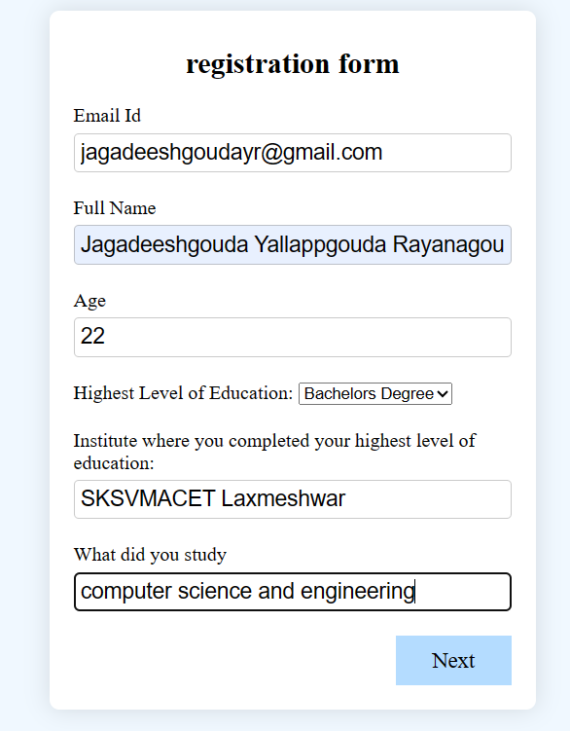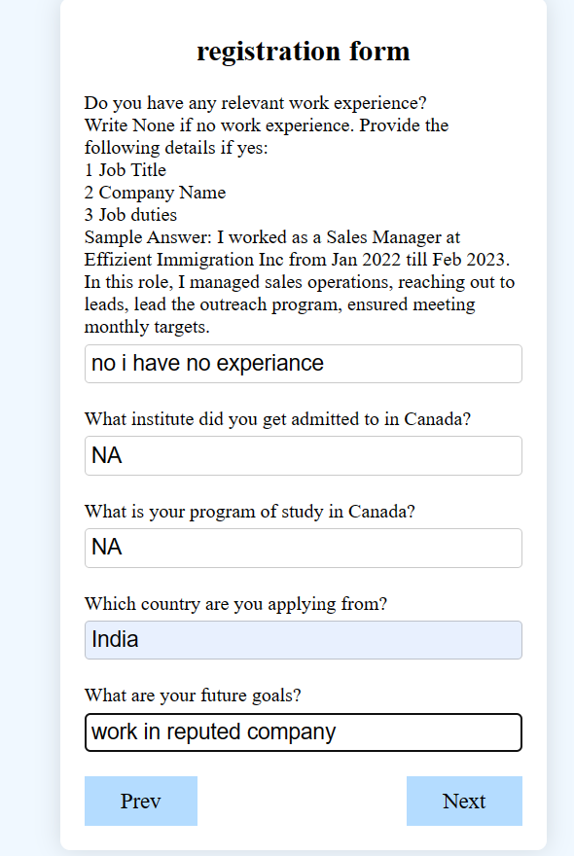
Fig1:- 1st page of the form Fig2:- 2nd page of the form
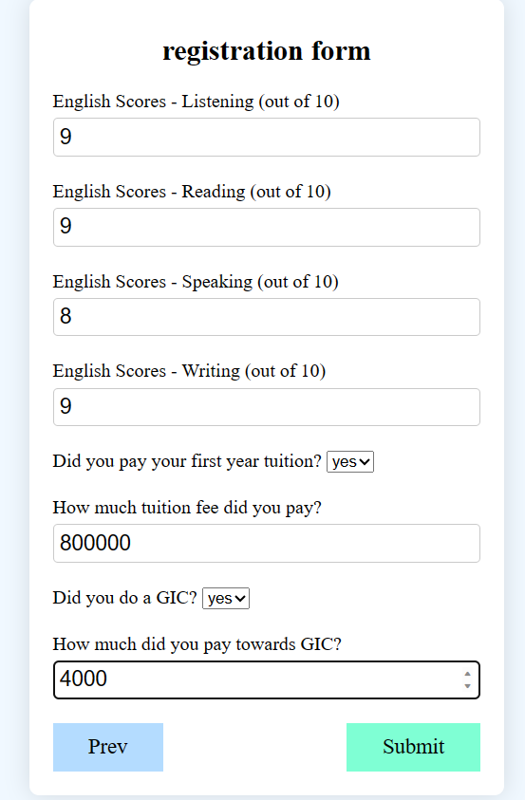
Fig3:- 3rd page of the form 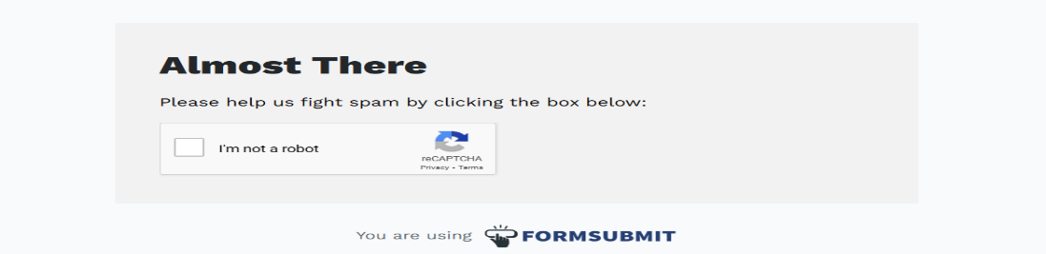

Fig 4:- after submission of the form
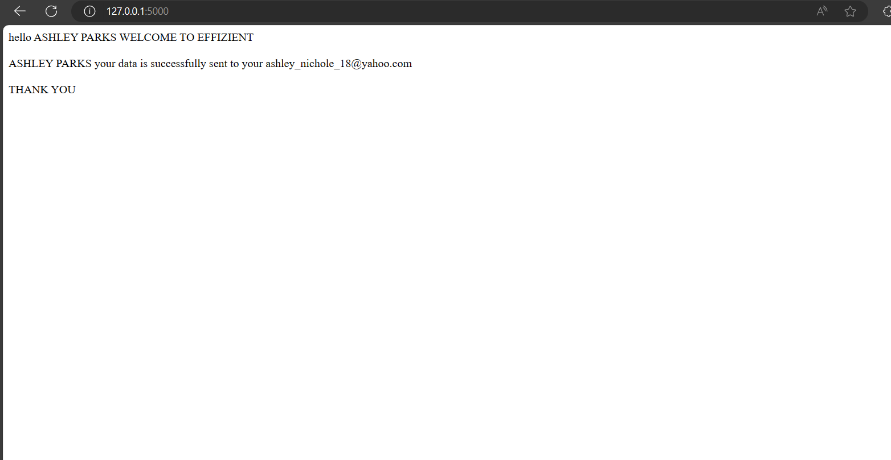
Fig 5:- confirmation message after entering the captcha.
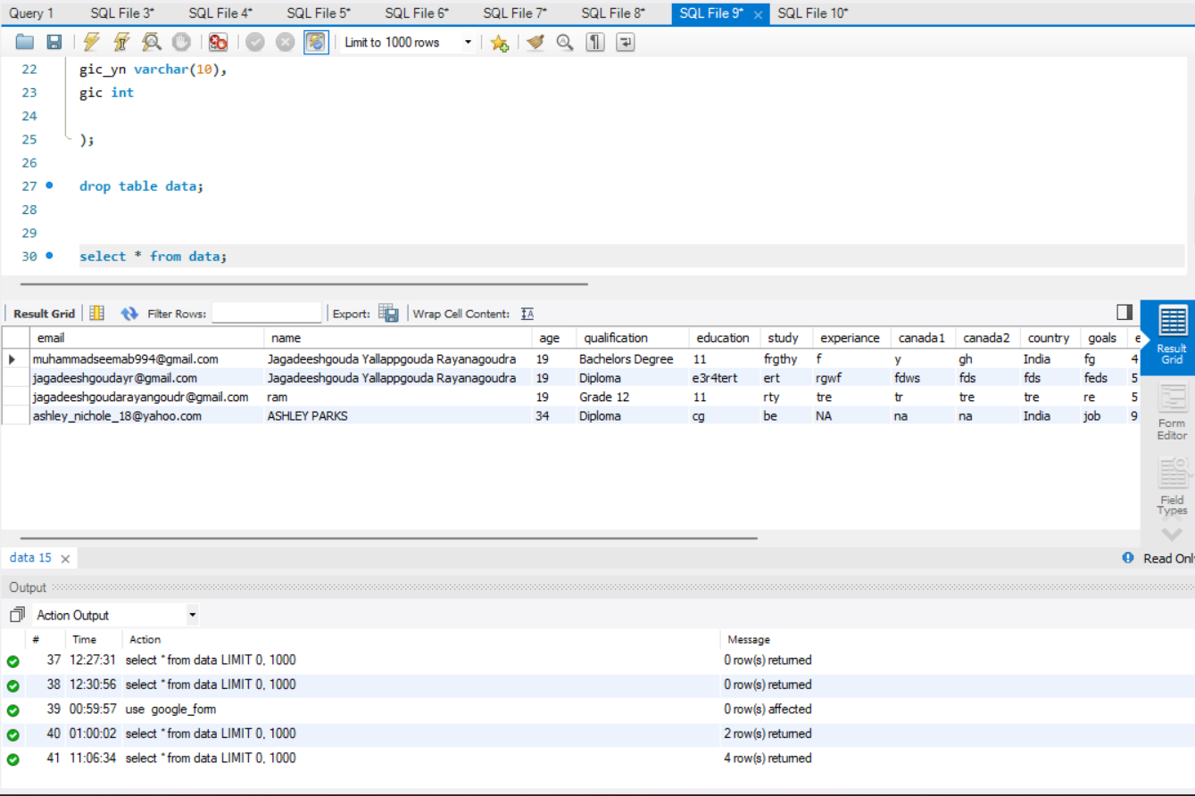
Fig 6:- database of the project

